Task 16 BYB for Shuyan Dong

Practice 1

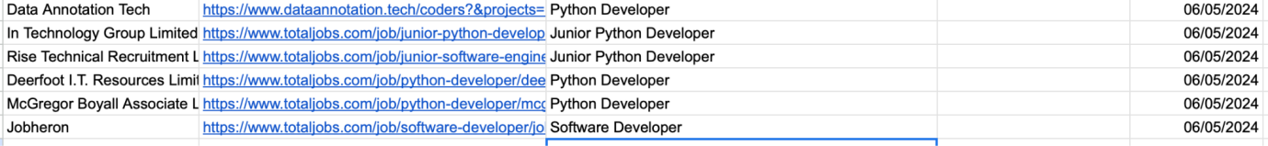

Shared link

[SY Dong Template Job Interviews/Pitch Opportunities Tracker](https://docs.google.com/spreadsheets/d/1b3YHIxur3M42Gqm40rwgId61y5g4e7bzHPzFMGY5Nik/edit#gid=0)

Practice 2

Updated CV saved in dropbox - please check dropbox for more details